|  |  |  |  |  |
| --- | --- | --- | --- | --- |
| **National University of Computer and Emerging Sciences, Lahore Campus** | | | | |
| C:\Users\saif\AppData\Local\Microsoft\Windows\Temporary Internet Files\Content.Word\final design.jpg | **Course:** | **Database Systems (Lab)** | **Course Code:** | **CS201** |
| **Program:** | **BS(Computer Science)** | **Semester:** | **Fall 2016** |
| **Duration:** | **2 Hours** | **Total Marks:** | **30** |
| **Paper Date:** | **17-03-2017** | **Weight** | **15%** |
| **Section:** | **B** | **Page(s):** | **2** |
| **Exam:** | **Lab Midterm Exam** | **Reg. No(Sec)** | **-------------( )** |
| **Instruction/Notes:** | * You are not allowed to use laptops, you will use lab computer on seat allotted to you. * Create your own database by your own roll number, using another database will result in penalty. * You are not allowed to open browsers, or any shared folders. * You are only allowed to open SQL server, manuals and reference material. * You will have to submit question paper to instructor at the end to exam * Attempt and submit each question in separated script file, add all files in one folder name as your roll number and submit the folder on Xeon. * It’s your responsibility to submit your exam within the given time, and make sure your submission has been made. No exceptions will be made otherwise. * Turn off your mobile phone a place on your tables. * Using any unfair mean and cheating will result in DC. | | | |

Use the given schema to attempt all questions. Your solution should work for all states of Database, not just the given one. A script file to create and populate schema is given in Twitter.sql file in following folder.

\\sandata\xeon\Ishaq\Database Systems (A, B)- Spring 2017\Lab(CS-B)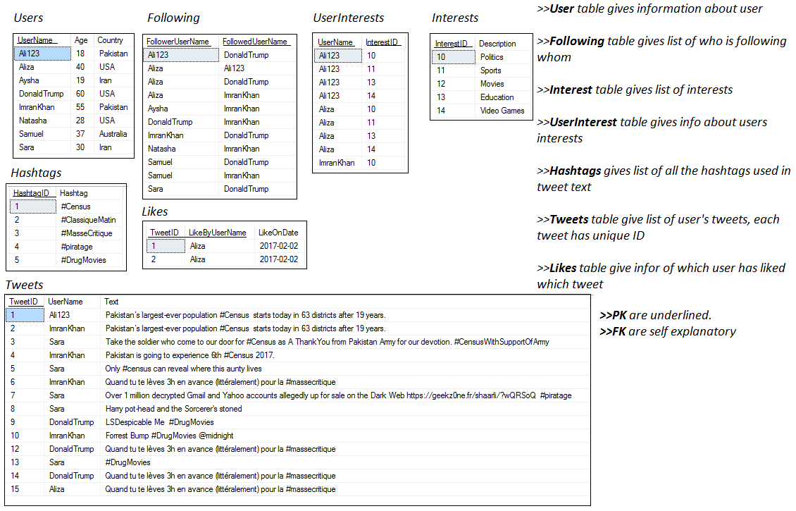

You have to implement the following functionalities.

**Functionality1: Find people to follow (10 points)**

Twitter has a functionality “Find people to follow”. Through this functionality twitter will give you a list of people that you might be interested in following, based on some common grounds. You have to create a store procedure to implement ‘Find people to follow’. This stored procedure will take a username as input and will give list of usernames of recommend “*People to Follow”*. Following people should be included in this list:

1. Users that have more than 3 people in their FOLLOWING list in common with the input user.
2. Users that have more than 5 followers and live in same region (Country) as input user.
3. Users that have more than 3 same interests as input user.
4. People that input user is already following should not be added in the list.

Write Execute statement of your procedure as well.

**Functionality 2: Notify Like (10 points)**

Whenever some user likes your tweet you get a notification as given below:

<Username> liked you tweet on <Date> : <TweetText>

You have to create a trigger such that whenever someone likes a tweet a Notification should be added in NotifyLikes table, but first you have to create NotifyLikes table. Following attributes should be added in this table

* **TweetID** , ID of tweet that was liked.
* **TweetByUserName**, UserName of person whose tweet was liked.
* **LikeByUseName**, username of person who liked the tweet.
* **Date**, date on which tweet was liked.
* **SeenFlag**, this will be a Boolean flag that will represent when the user has seen the notification or not. Initially it will be 0.

Properly identify that what type of trigger you have to use and on which table it should be created on. Perform an event to execute the trigger

**Functionality 3: Trending Hashtags (10 points)**

This functionality will give a list of top 3 most used hashtags in current week. Create a view that gives Hashtag and number of times it has been used.

Notes: More than one hashtag can be used in one tweet. Also assume that one hashtag will be used only single time in one tweet.